How to Stop Your Android Phone From Tracking You
By Ayush Jalan
Published 2 days ago
Your Android phone is tracking you in many ways. Here are eight steps you can take to stop it.

No matter where you go online, you're being tracked. Apps and websites constantly monitor your activity and collect your data for all sorts of reasons. Your physical location, buying behavior, and media consumption habits all leave a trail every time you pick up your phone.
If privacy is a big deal for you, this is enough to invite a lot of fear and anxiety. In this guide, we'll show you eight ways you can stop your Android phone from tracking you.

1. Turn Off Location, Wi-Fi, and Mobile Data
The easiest way to stop your Android phone from tracking you is to simply turn off location tracking, Wi-Fi, and mobile data. Restricting these services basically makes your phone unable to connect to the outside world. If you want to go a step beyond and block your cellular network as well, simply turn on Airplane mode.
You can do this by accessing your Quick Settings panel. Although convenient, this solution isn't ideal since you obviously require an active internet connection and cellular network to use your phone like normal; still, if you need some peace of mind, this method helps.

2. Pause or Delete Your Google Activity
It's not news to anyone at this point that Google has a lot of data on you. This data is divided into three categories: Web & App Activity, Location History, and YouTube History. You can view and manage this data in the Google app.
Follow the steps below to pause your Google activity:
- Open the Google app and tap on your profile picture.
- Tap Manage your Google Account and go to the Data & privacy tab.
- Under History settings, tap Web & App Activity > Turn off > Pause.
- Do the same for Location History and YouTube History.
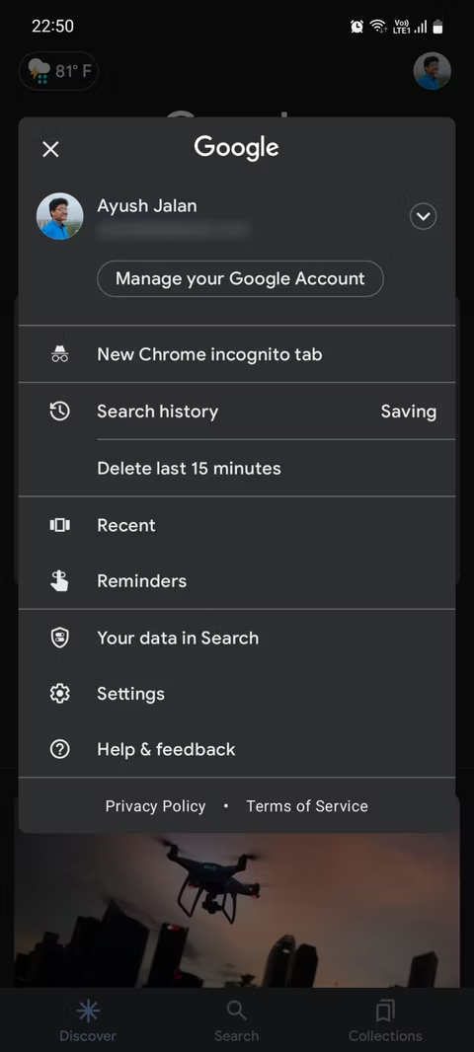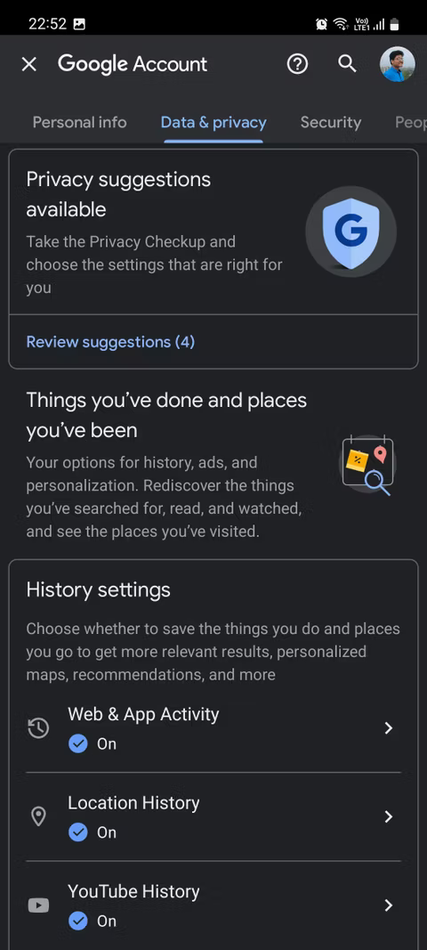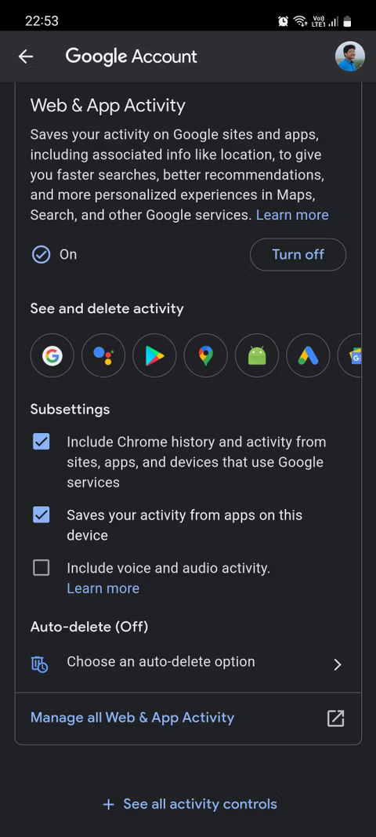
Follow the steps below to delete your Google activity:
- Under History settings, tap Web & App Activity > Manage all Web & App Activity.
- Tap Filter by date & product in case you want to remove particular items only.
- Tap Delete and select if you want to delete activity from the Last hour, Last day, All time, or set a custom range.
  - You can also tap Set up automatic deletions to remove your activity at regular intervals. Select to auto-delete activity older than three, 18, or 36 months.
- You might be asked to select which activity to delete on the next screen. Select your activity and tap Next > Delete.
- Do the same for Location History and YouTube History.
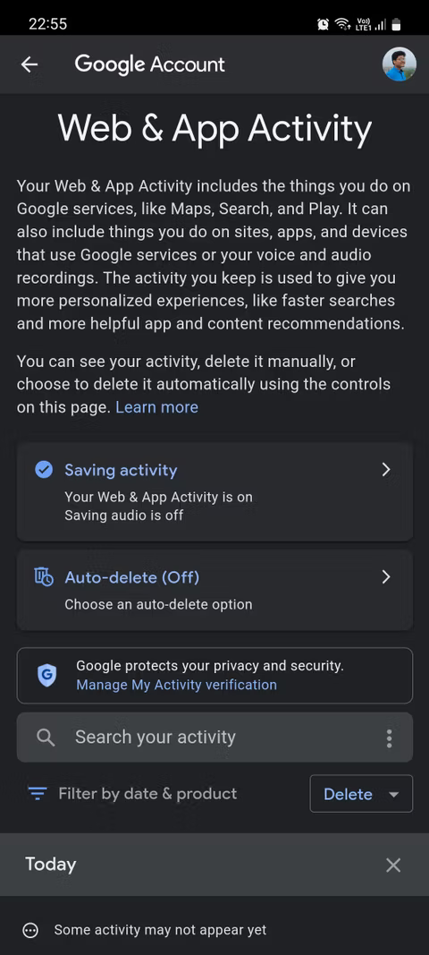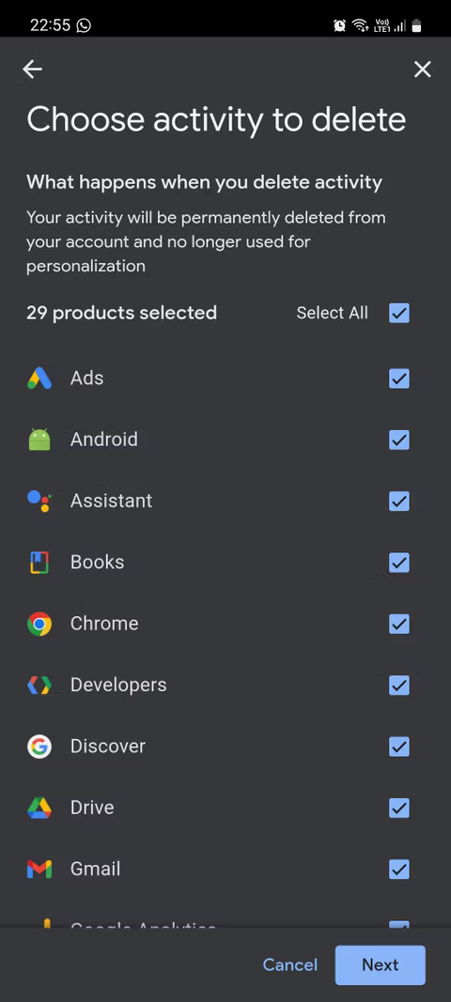

3. Turn Off Personalized Search Results
Another way to limit tracking on your phone is to stop seeing personal search results. Doing so means that when you search for something on Google, you will no longer see results that are the most relevant to you, but rather more general results about the searched topic.
Here's how to do this:
- Open the Google app and tap on your profile picture.
- Go to Settings > Personal results.
- Tap the toggle switch to disable personal search results.
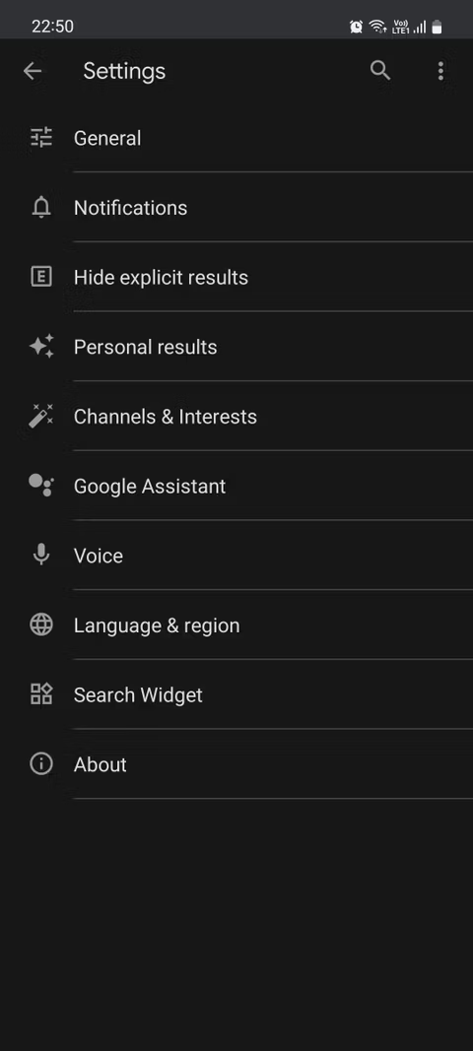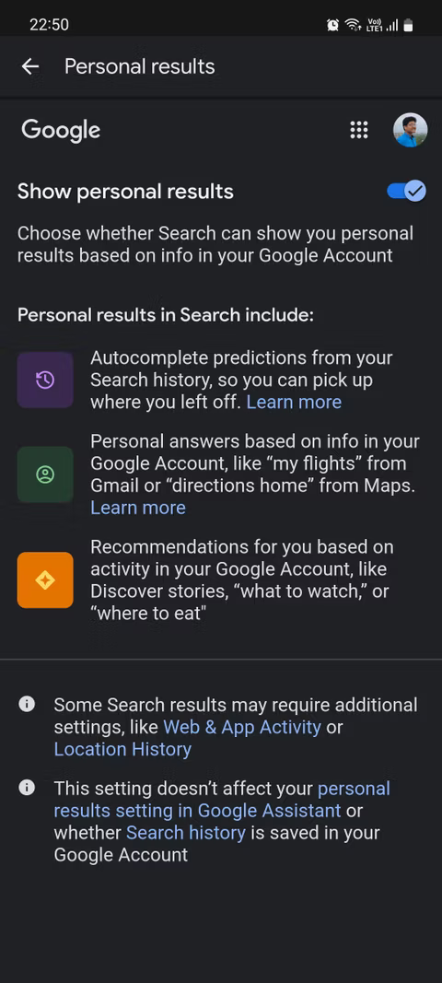

4. Turn Off Ad Personalization
Similar to the last point, you can also stop seeing personalized ads if they are getting a bit too intrusive for your comfort level. Note that this doesn't mean you'll stop seeing ads altogether; you'll still see ads, but they'll just not be as relevant to you.
Here's how to disable ad personalization:
- Open the Google app and tap on your profile picture.
- Tap Manage your Google Account and go to the Data & privacy tab.
- Under Ad settings, tap Ad personalization.
- Tap the toggle switch to disable personalized ads.
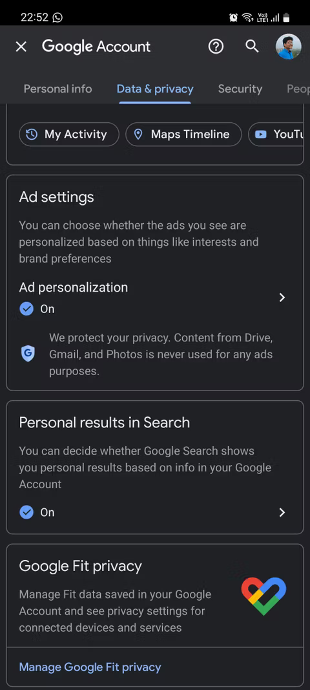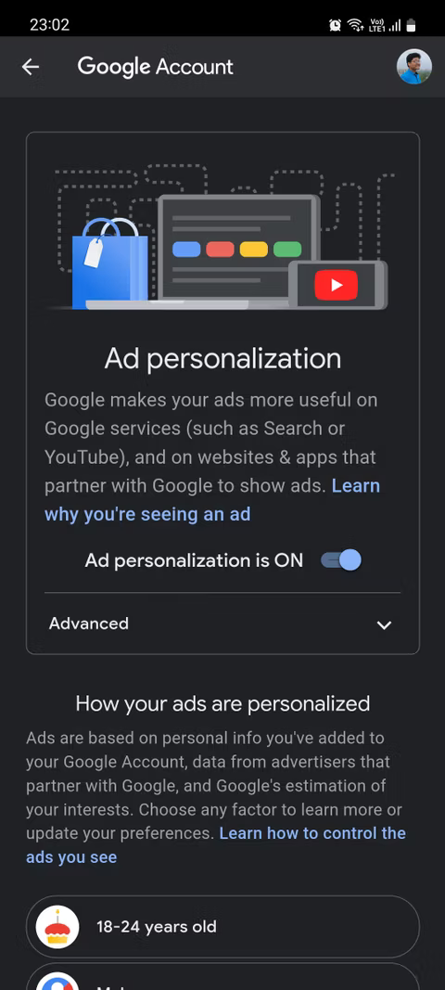

5. Delete Your Advertising ID
Every Android device has a unique advertising ID that contains information about the user, their preferences, habits, and more. You can delete the advertising ID stored on your device to stop apps from using it to show you personalized ads and content.
Here's how to do this:
- Go to Settings > Google > Ads.
- Tap Delete advertising ID and tap Delete advertising ID again to confirm.
  - Alternatively, you can also tap Reset advertising ID to start fresh from a clean slate.
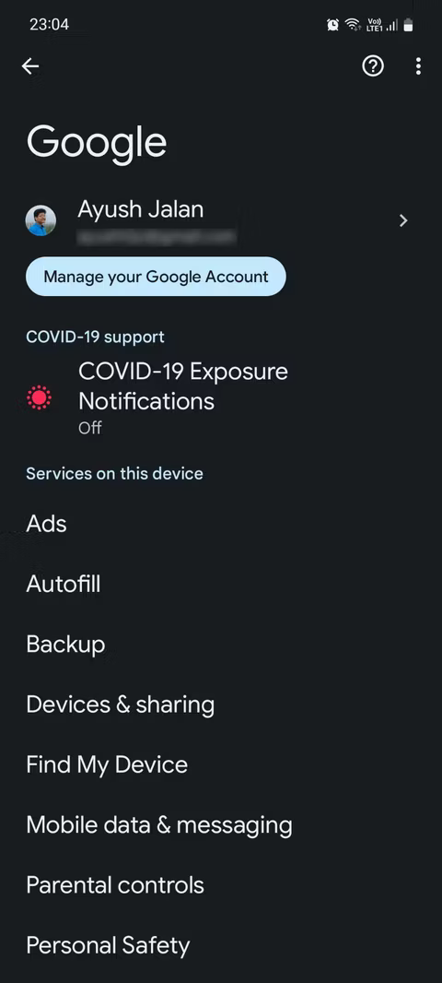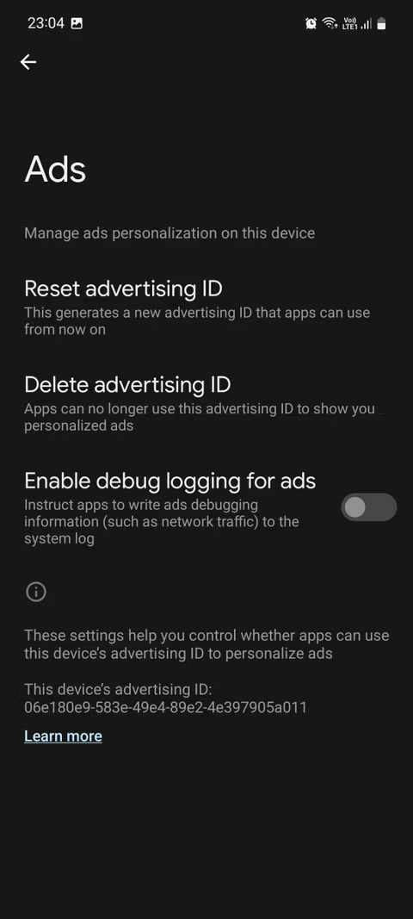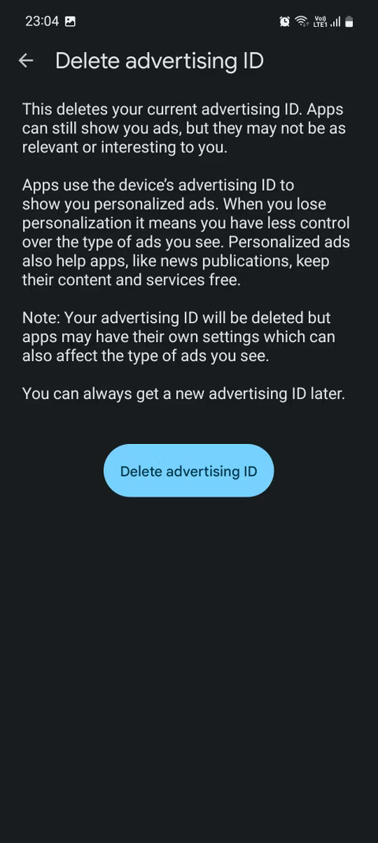

6. Remove Permissions From Unused Apps
There are a variety of permissions such as your location, camera, microphone, calendar, files, and call logs that you instinctively grant to an app when you install it. Through these permissions, apps can access your data, store it, and use it for advertising purposes. Luckily, you can remove these permissions any time you want.
Here's how to do so:
- Go to Settings > Privacy > Permission manager.
- Tap a permission to see which apps are using it.
- Tap an app under Allowed and select Don't allow.
- If prompted with a warning, tap Don't allow anyway.
  - Alternatively, you can select Ask every time or Allow only while using the app.
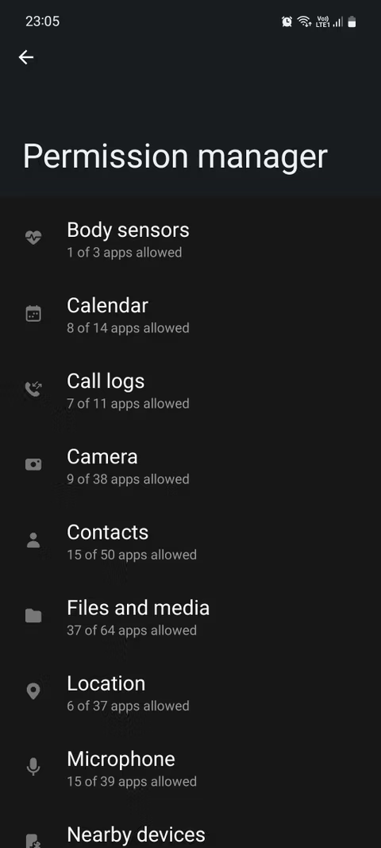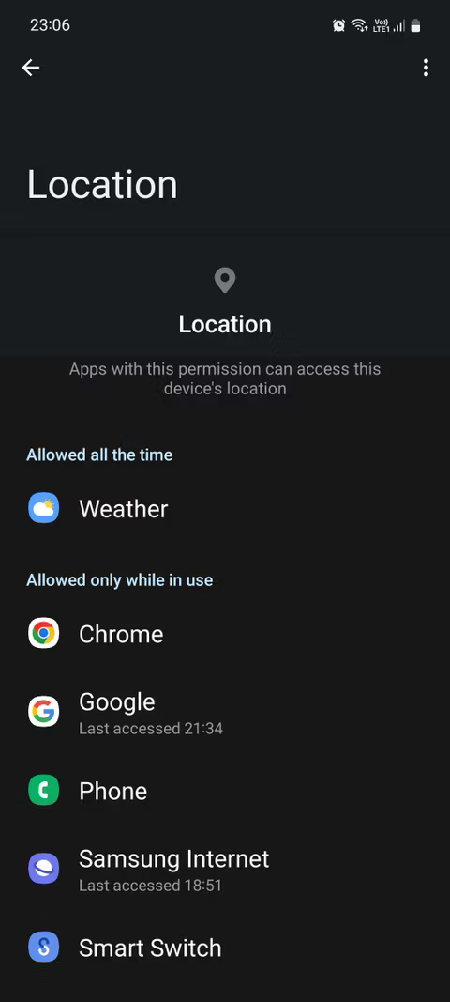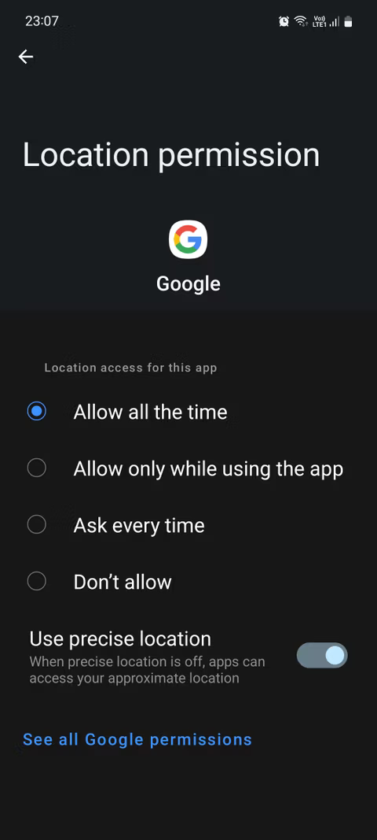
To see all the permissions an app has, go to its details page and select Permissions.

7. Uninstall Apps You Don't Need
It's a simple rule of thumb that the more apps you have, the more tracking is possible. So, to minimize your chances of being tracked, it's a good idea to uninstall the non-essential apps on your phone. This includes pre-installed bloatware apps, social media apps, dating apps, fitness apps, and more.
Do note that some pre-installed apps cannot be uninstalled. In that case, your only option is to disable them to stop them from running in the background—unless you want to risk rooting your Android phone which is not a popular recommendation these days.

8. Switch to Privacy-Friendly Alternatives
Since privacy is becoming an increasingly important matter, several developers have made it their mission to provide you with privacy-friendly apps and websites that you can use as an alternative to your current apps. For instance, you can use Brave instead of Google Chrome, replace the Google Play Store with its alternatives, and ditch WhatsApp for Signal.
Don't download anti-tracking apps as they are unreliable and often end up collecting your data for advertising—which defeats their whole purpose.

Prevent Your Android Phone From Being Tracked
No matter how much you try to disable tracking on your phone, it's virtually impossible that you will become fully untraceable. As long as your phone is with you, it's likely to send some kind of data to the outside world—even if you're using privacy-friendly apps.
In fact, there are a fair number of lawsuits against Google claiming the company tracks its users despite them turning off location history and other similar settings.
This is the unfortunate side effect of having increasingly integrated tech ecosystems surrounding us. The more connected you are to technology, the easier it becomes to track you. Fortunately, there are ways you can at least reduce how frequently you're being tracked.

