How to mirror an iPhone's screen on PC
Note: these tips will also work for iPads supporting AirPlay.
1. To get LonelyScreen, head to its download page (opens in new tab) to download and install it. After installing the app on your Windows PC, open it and click Maybe Later to try it out. Connect your Windows PC and iPhone or iPad to the same Wi-Fi network.
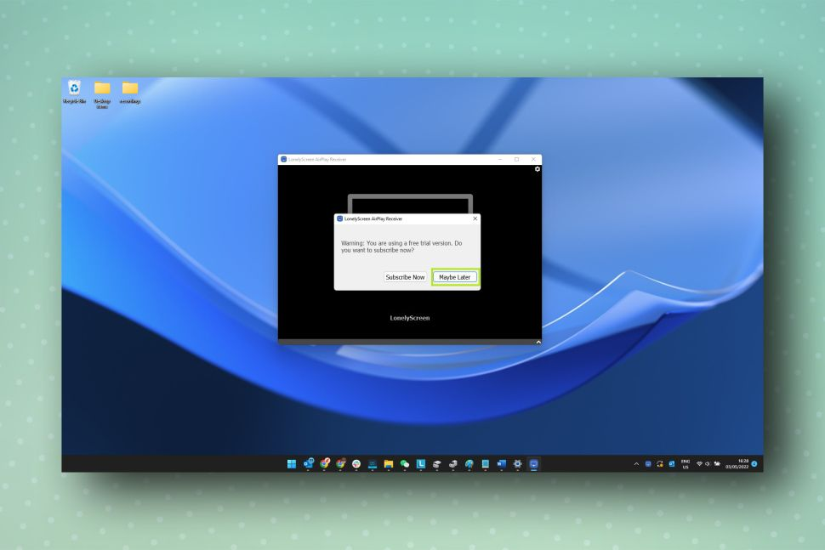
(Image credit: Future)
2. Now, on your iPhone or iPad, swipe down from the top-right corner to open the Control Center. Next, tap the Screen Mirroring icon.
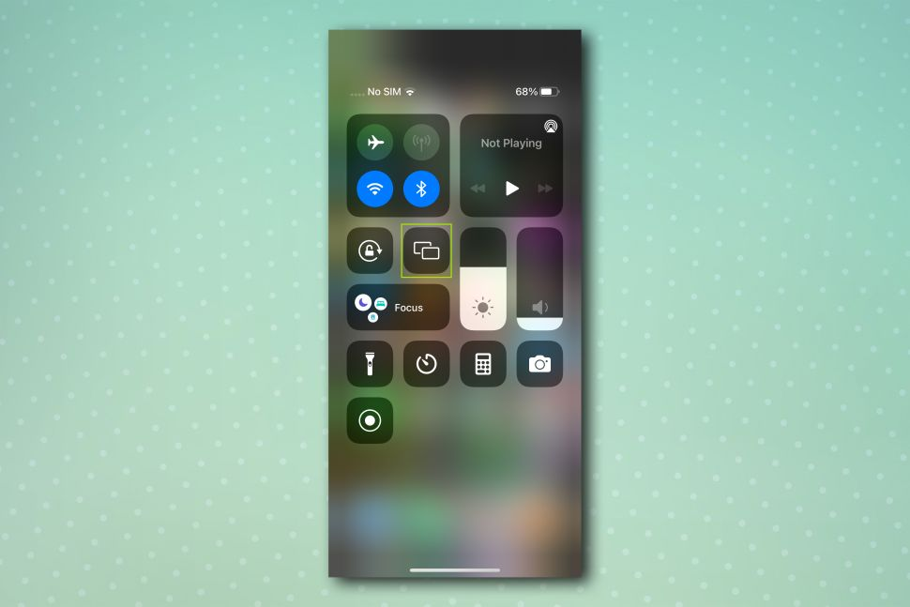
(Image credit: Future)
3. You should now see LonelyScreen as an available option. Simply tap it to begin mirroring.
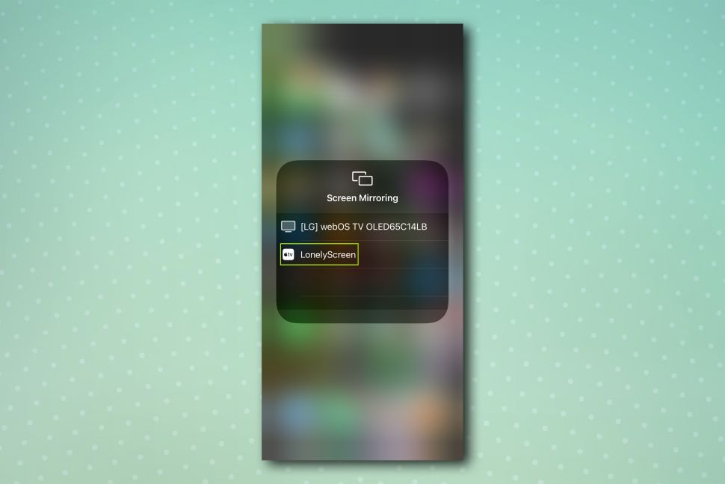
(Image credit: Future)
And that's it! You're now mirroring your screen as if you were a Mac user.
A number of paid apps also exist, including Reflector 4 (opens in new tab) and AirServer (opens in new tab), as well as a several other free apps, a bunch of which can be found on the Microsoft Store (opens in new tab).
If you're just looking to quickly mirror your iPhone to your PC to share a presentation or play a quick game on your living room TV, it may not be worth splashing the cash. However, the paid apps do offer more advanced features, such as the ability to also mirror a Chromebook, Mac, or other devices to your PC.

